THE COLUMBIA JOURNAL OF TRANSNATIONAL LAW PRESENTS
THE 49TH ANNUAL
WOLFGANG FRIEDMANN MEMORIAL AWARD BANQUET
Honoring
Judge Navi Pillay
March 28th, 2023
The University Club of New York

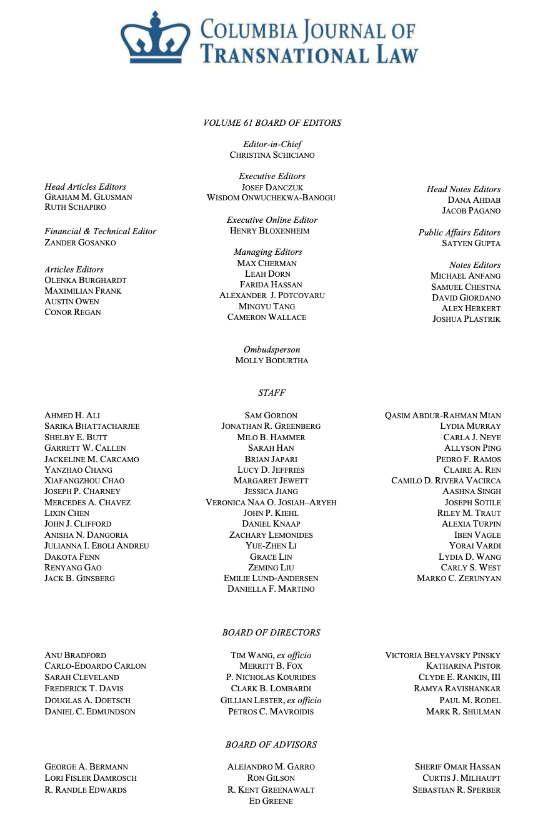

PROGRAM
INTRODUCTION FROM THE COLUMBIA JOURNAL OF TRANSNATIONAL LAW
Josef Danczuk & Wisdom Onwuchekwa-Banogu
Executive Editors, Columbia Journal of Transnational Law

WELCOME AND INTRODUCTION OF THE WOLFGANG FRIEDMANN AWARD

Gillian Lester (comments read by P. Nicholas Kourides)
Dean of the Faculty of Law and Lucy G. Moses Professor of Law

P. Nicholas Kourides
Chairman of the Board, Columbia Journal of Transnational Law

REMARKS ON THE LEGACY OF PROFESSOR FRIEDMANN
Will Freeman, Ph.D
Fellow for Latin American Studies, Council on Foreign Relations
INTRODUCTION OF THE AWARD RECIPIENT
Sarah Cleveland
Louis Henkin Professor of Human and Constitutional Rights
ACCEPTANCE ADDRESS
Judge Navi Pillay
2023 Wolfgang Friedmann Memorial Award Recipient
UN High Commissioner for Human Rights, 2008-2014
ANNOUNCEMENT OF STAFFER AWARDS
Josef Danczuk and Wisdom Onwuchekwa-Banogu
Executive Editors, Columbia Journal of Transnational Law

Prizewinners:

Lucy Jeffries

Daniel Knaap

Lydia Murray

Allyson Ping

Milo Hammer

Riley Traut
YEAR END REMARKS & ANNOUNCEMENT OF THE NEIL MCDONNELL MEMORIAL PRIZES FOR OUTSTANDING SERVICE TO THE JOURNAL
Christina Schiciano
Editor-in-Chief, Columbia Journal of Transnational Law
Prizewinners:
Ruth Schapiro, Head Articles Editor
Zander Gosanko, Financial & Technical Editor
Max Cherman, Managing Editor
Molly Bodurtha, Ombudsperson
David Giordano, Notes Editor

PAST FRIEDMANN AWARD RECIPIENTS

2022: Christiana Figueres
2021: Justice Ruth Bader Ginsburg 2020: Judge Joan E. Donoghue 2019: Rt. Hon. David
Miliband
2018: Dr. Anne-Marie Slaughter
2017: Justice Stephen Breyer 2016: Martti Ahtisaari
2015: Lori Fisler Damrosch 2014: Aryeh Neier
2013: Dr. Shirin Ebadi
2012: M. Cherif Bassiouni 2011: George J. Mitchell 2010: Jerome A. Cohen 2009: James Crawford
2008: Antônio Augusto Cançado Trindade
2007: Justice Sandra Day O’Connor
2007: Antonio Cassese 2006: Ian Brownlie
2005: Richard N. Gardner 2004: Giuliano Amato
2003: Harold Hongju Koh 2002: Hans Blix
2001: Louise Arbour

2000: Hon. Gabrielle Kirk Mcdonald
1999: Thomas Franck
1998: Stephen M. Schwebel 1997: Conrad K. Harper
1996: James A. Baker III
1995: Boutros Boutros-Ghali 1994: Max M. Kampelman 1993: Michael H. Posner
1992: John J. Jackson
1991: Sen. Daniel Moynihan
1990: John N. Hazard
1989: Thomas Buergenthal 1988: John R. Stevenson 1987: Keith Highet
1986: Louis Henkin
1985: Hon. Rosalyn Higgins 1984: Tommy Koh
1983: Oscar Schachter 1982: Maxwell Cohen 1981: Telford Taylor
1980: Alona E. Evans
1979: Hardy C. Dillard 1978: Willis M Reese
1977: Arthur H. Dean
1976: Oliver S. Lissitzyn 1975: Philip C. Jessup

49TH ANNIVERSARY RECIPIENT: Judge Navi Pillay 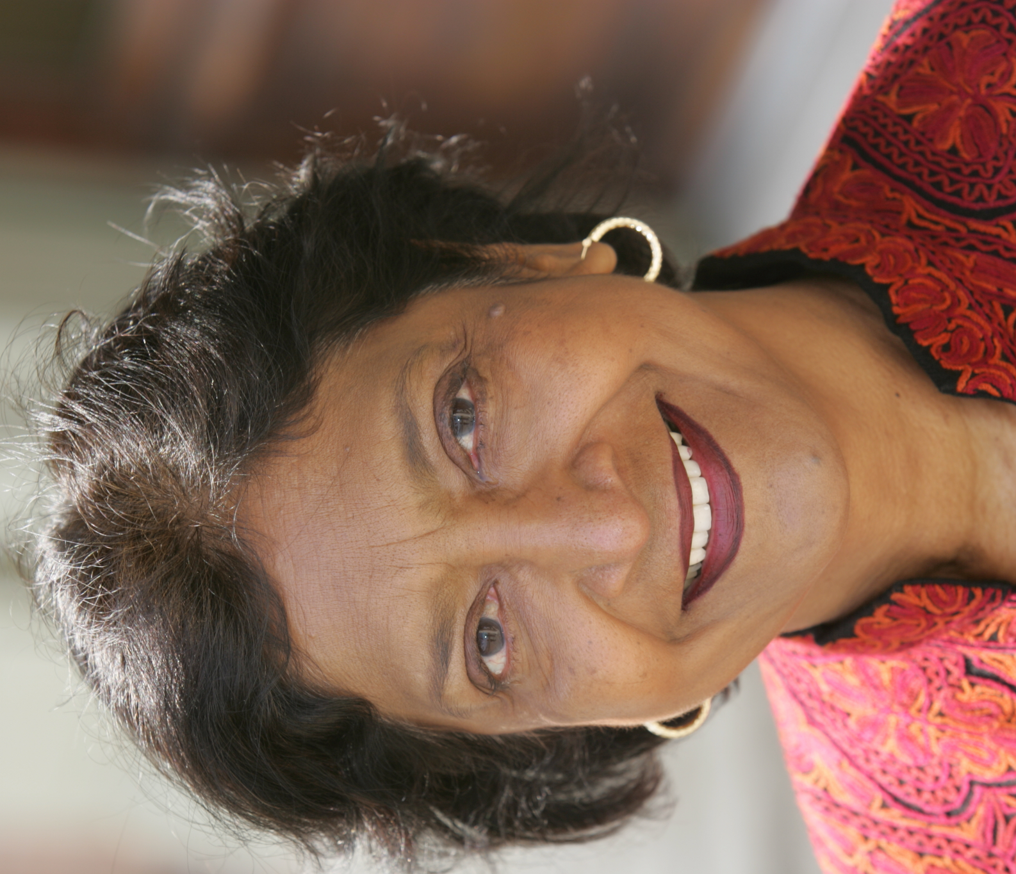

As Former United Nations High Commissioner for Human Rights, Judge of the International Criminal Court, and President of the International Criminal Tribunal for Rwanda, Judge Navi Pillay is an internationally recognized leader in international law and human rights. During her time as High Commissioner from 2008-2014, Judge Pillay took critical steps to defend the rights of LGBTQ people and led the organization through the opening stages of the Syrian Civil War. As President of the International Criminal Tribunal for Rwanda (ICTR), she played an important role in the landmark trial of Jean-Paul Akayesu, establishing that sexual assault could constitute an act of genocide.

Judge Pillay, a South African national, was the first woman to start a law practice in her home province of Natal in 1967. Over the next few years, she acted as a defense attorney for anti-apartheid activists helping to establish key rights for prisoners on Robben Island. She also worked as a lecturer at the University of KwaZulu-Natal, and later was appointed Vice-President of the Council of the University of Durban Westville. In 1995, Judge Pillay was appointed as acting judge on the South African High Court, and in the same year was elected by the UN General Assembly to be a judge on the International Criminal Tribunal for Rwanda. In 2003, she was appointed as a judge on the International Criminal Court in the Hague, where she served on the Appeals until August 2008.
Throughout Judge Pillay’s career, she has addressed some of the most pressing international law issues of our time, spanning a remarkable geographic range.

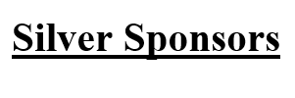
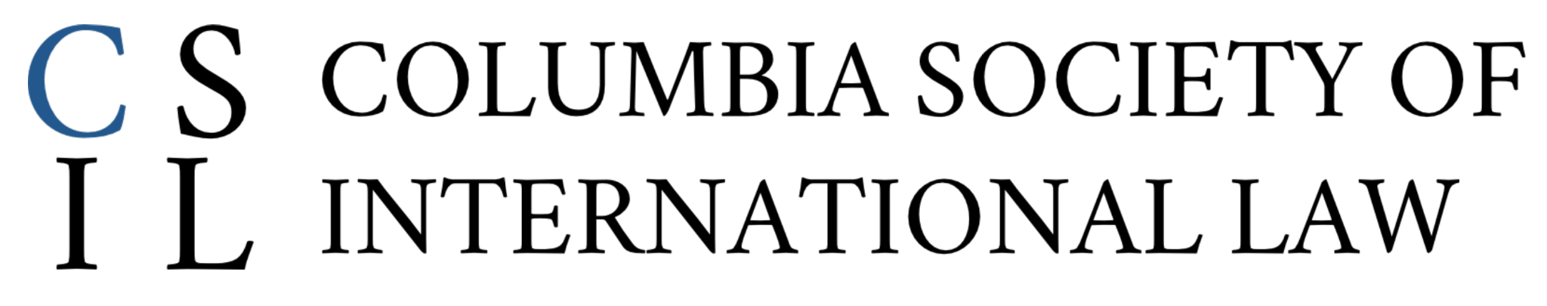
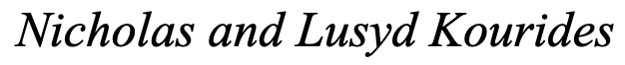

The Columbia Journal of Transnational Law would like to express its heartfelt thanks to its Board of Directors and the Editorial Board and Staff for all their hard work this year on the Journal and in planning the Friedmann Award Banquet.

Please consider supporting the continued publication of international legal scholarship by making a charitable donation to the Columbia Journal of Transnational Law:

DONATION OPTIONS

_____ Check made payable to “Columbia Journal of Transnational Law,”
including “Friedmann Donation” in the memo line.
_____ Please charge my Visa/MC #_________________ Exp. _______
CVV______ Donation Amount _________
_____ The Journal’s website at https://www.jtl.columbia.edu/donate
_____ Venmo @CJTLFriedmann. If you are asked to input the last four
digits of a phone number, please enter “1326.”

Signature: _____________________________________________

Date: ___________ Name: _______________________________

Email: _______________________________________________

Address: ______________________________________________

City: ___________________ State: ___________ ZIP: _________

